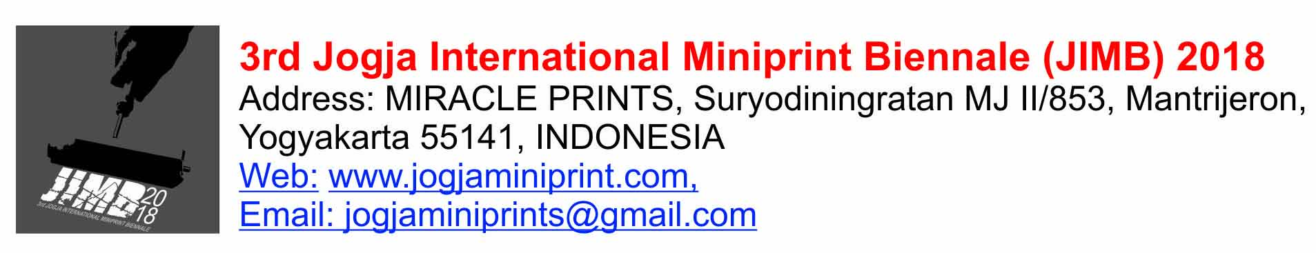
FORMULIR PESERTA/ ENTRY FORM (Untuk disertakan dalam pengiriman karya / This form should be included with works submitted for consideration his. DEADLINE receive of works 10 September 2018

FEE Submission
Self Photo attached here

(Mohon diisi dengan huruf cetak/Please use block letters)
NO. PENDAFTARAN/APPLICATION NUMBER

NAMA LENGKAP/FULL NAME: | TANGGAL LAHIR/DATE OF BIRTH:
KEWARGANEGARAAN/NATIONALITY: | MALE / FEMALE:
PENDIDIKAN/EDUCATION: | ALAMAT SURAT/MAILING ADDRESS:  JALAN/STREET:  KOTA/CITY:  NEGARA/COUNTRY:  KODE POS/POST CODE:
TELEPHONE / MOBILE PHONE: | E-MAIL:
WEBSITE/BLOG: | Any Links:
3 PAMERAN PENTING TERAKHIR /PLEASE LIST 3 RECENT EXHIBITIONS: | AWARDS/GRANTS/RESIDENCIES:
DATA KARYA/LIST OF WORKS SUBMITTED:
WORK 1.

.JUDUL/TITLE :

TEKNIK/TECHNIQUE :

IMAGE SIZE:
PAPER SIZE:
NO. EDISI/EDITION NUMBER : /
TAHUN/YEAR :
HARGA/PRICE : IDR/USD

WORK 2.

.JUDUL/TITLE :

TEKNIK/TECHNIQUE :

IMAGE SIZE:
PAPER SIZE:
NO. EDISI/EDITION NUMBER : /
TAHUN/YEAR :
HARGA/PRICE : IDR/USD

WORK 3.

.JUDUL/TITLE :

TEKNIK/TECHNIQUE :

IMAGE SIZE:
PAPER SIZE:
NO. EDISI/EDITION NUMBER : /
TAHUN/YEAR :
HARGA/PRICE : IDR/USD

WORK 4.

.JUDUL/TITLE :

TEKNIK/TECHNIQUE :

IMAGE SIZE:
PAPER SIZE:
NO. EDISI/EDITION NUMBER : /
TAHUN/YEAR :
HARGA/PRICE : IDR/USD

Dengan ini menyetujui persyaratan yang berlaku dalam 3rd JIMB 2018 / I accept the Terms and Conditions of 3rd JIMB 2018
Tanggal/Date:………………………………….2018 | Tanda tangan peserta/Signature : | Nama Terang/Name of participant:

TO: Secretariat 3rd JIMB 2018

d/a: MIRACLE PRINTS
SURYODININGRATAN MJ. II/853, MANTRIJERON,
YOGYAKARTA 55141, INDONESIA
Tel: +62 81328672943

Label untuk ditempel disebalik karya/Label to be attached on the back of works submitted
WORK 1.  Artist:  JUDUL/TITLE :  TEKNIK/TECHNIQUE :  IMAGE SIZE:  NO. EDISI/EDITION NUMBER : /  TAHUN/YEAR : | WORK 2.  Artist:  JUDUL/TITLE :  TEKNIK/TECHNIQUE :  IMAGE SIZE:  NO. EDISI/EDITION NUMBER : /  TAHUN/YEAR :
WORK 3.  Artist:  JUDUL/TITLE :  TEKNIK/TECHNIQUE :  IMAGE SIZE:  NO. EDISI/EDITION NUMBER : /  TAHUN/YEAR :: | WORK 4.  Artist:  JUDUL/TITLE :  TEKNIK/TECHNIQUE :  IMAGE SIZE:  NO. EDISI/EDITION NUMBER : /  TAHUN/YEAR :

